Convert Customers

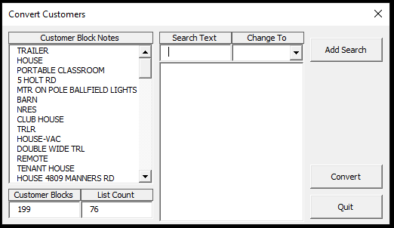

Most of the time the type of customer is noted in the Note block attribute and this is what this program uses to change the customer type. It will search for the Search Text within the attribute and if it is found, change the customer type.

When the program starts, is searches the drawing for all of the Customer blocks and adds the NOTE attribute to the Customer Block Notes listbox. It will not duplicate the list item if the text is already on the list. You can double click on an item in the list and the text will be entered into the Seach Text textbox. You can also click on an item and hit the delete key to remove the item from the list. This should be helpful in seeing what you have left to search for. In this example the Customers type is defaulted to RESIDENCE. We could remove all houses from the list to make searching the list easier. That makes the list count go from 76 to 38 in this example.

The first item of the list remaining is TRAILER. You can double click the list item to add the item to the Search Text textbox, select TRAILER in the combobox, and click Add Search to add it to the search criteria.

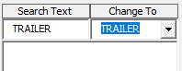 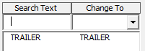

Once you have added all the search criteria, click on the Convert button to change the Customer Types.